42.55: a) 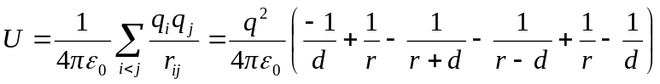
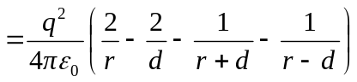
but 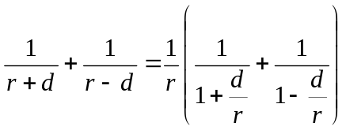
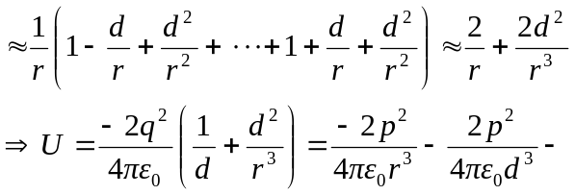
b) 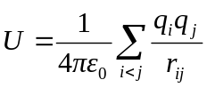
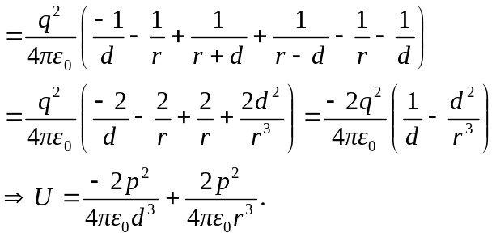
If we ignore the potential energy involved in forming each individual molecule, which just involves a different choice for the zero of potential energy, then the answers are:
a) 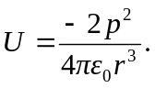 b) 